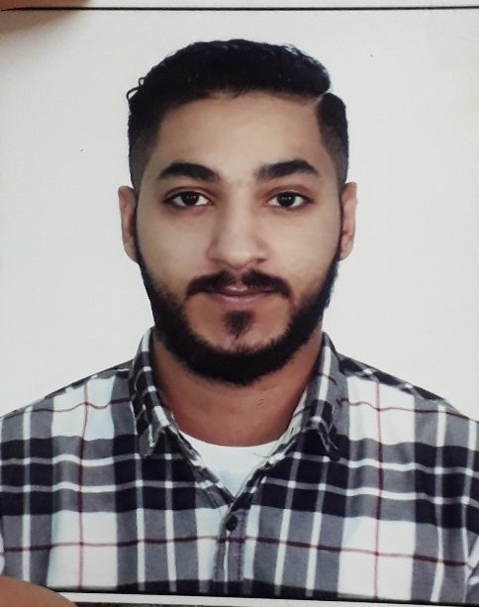

Hassan Ahmed Mohamed

* Flat 13 Building 2212 Road 2027 lowzi 1020

AL lowzi - Bahrain

* Mobile No: 34440616 - 34050446

Objective

To seek a challenging position in a reputable organization where my knowledge can be shared, enriched and contribute my career to the organization working sincerely with commitment.

Personal Information

Birthday : November 21, 1993

Birthplace : Manama

Civil Status : Married

Nationality : Bahraini

Languages known: English & Arabic & Indian

Religion : Muslim

CPR No. : 931111480

Educational Attainment

Primary

* AL Motanbi Primary Boys School

Intermediate

* Abdu AL rahman AL dakhel Intermediate Boys School

Secondary

* Commerce Student
* Ahmed AL omran Secondary Boys School
* Graduated on 2009

Work Experience

* Worked in engineer hospital as a security.
* Worked in G4s security company as security.
* Worked in AL Nasser pharmciy.

Skills

* Computer literate Microsoft Office (Word, Excel, Power Point, Access).
* Visual Basic.
* Movie Maker.

Hobbies

* Surfing on the Internet.
* Reading Magazines.
* Photography.

Qualification

* Flexible, Hardworking
* Team player
* Sociable with people